



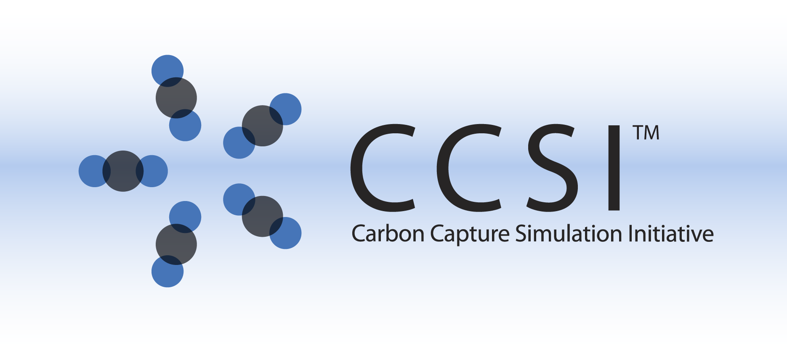

Superstructure Formulation

User Manual

**Version 2.0.0**

**March 2018**

Copyright (c) 2012 - 2018

**Copyright Notice**

Superstructure Formulation was produced under the DOE Carbon Capture Simulation Initiative (CCSI), and is copyright (c) 2012 - 2018 by the software owners: Oak Ridge Institute for Science and Education (ORISE), Los Alamos National Security, LLC., Lawrence Livermore National Security, LLC., The Regents of the University of California, through Lawrence Berkeley National Laboratory, Battelle Memorial Institute, Pacific Northwest Division through Pacific Northwest National Laboratory, Carnegie Mellon University, West Virginia University, Boston University, the Trustees of Princeton University, The University of Texas at Austin, URS Energy & Construction, Inc., et al.. All rights reserved.

NOTICE. This Software was developed under funding from the U.S. Department of Energy and the U.S. Government consequently retains certain rights. As such, the U.S. Government has been granted for itself and others acting on its behalf a paid-up, nonexclusive, irrevocable, worldwide license in the Software to reproduce, distribute copies to the public, prepare derivative works, and perform publicly and display publicly, and to permit other to do so.

**License Agreement**

Superstructure Formulation Copyright (c) 2012 - 2018, by the software owners: Oak Ridge Institute for Science and Education (ORISE), Los Alamos National Security, LLC., Lawrence Livermore National Security, LLC., The Regents of the University of California, through Lawrence Berkeley National Laboratory, Battelle Memorial Institute, Pacific Northwest Division through Pacific Northwest National Laboratory, Carnegie Mellon University, West Virginia University, Boston University, the Trustees of Princeton University, The University of Texas at Austin, URS Energy & Construction, Inc., et al. All rights reserved.

Redistribution and use in source and binary forms, with or without modification, are permitted provided that the following conditions are met:

1. Redistributions of source code must retain the above copyright notice, this list of conditions and the following disclaimer.
2. Redistributions in binary form must reproduce the above copyright notice, this list of conditions and the following disclaimer in the documentation and/or other materials provided with the distribution.
3. Neither the name of the Carbon Capture Simulation Initiative, U.S. Dept. of Energy, the National Energy Technology Laboratory, Oak Ridge Institute for Science and Education (ORISE), Los Alamos National Security, LLC., Lawrence Livermore National Security, LLC., the University of California, Lawrence Berkeley National Laboratory, Battelle Memorial Institute, Pacific Northwest National Laboratory, Carnegie Mellon University, West Virginia University, Boston University, the Trustees of Princeton University, the University of Texas at Austin, URS Energy & Construction, Inc., nor the names of its contributors may be used to endorse or promote products derived from this software without specific prior written permission.

THIS SOFTWARE IS PROVIDED BY THE COPYRIGHT HOLDERS AND CONTRIBUTORS "AS IS" AND ANY EXPRESS OR IMPLIED WARRANTIES, INCLUDING, BUT NOT LIMITED TO, THE IMPLIED WARRANTIES OF MERCHANTABILITY AND FITNESS FOR A PARTICULAR PURPOSE ARE DISCLAIMED. IN NO EVENT SHALL THE COPYRIGHT OWNER OR CONTRIBUTORS BE LIABLE FOR ANY DIRECT, INDIRECT, INCIDENTAL, SPECIAL, EXEMPLARY, OR CONSEQUENTIAL DAMAGES (INCLUDING, BUT NOT LIMITED TO, PROCUREMENT OF SUBSTITUTE GOODS OR SERVICES; LOSS OF USE, DATA, OR PROFITS; OR BUSINESS INTERRUPTION) HOWEVER CAUSED AND ON ANY THEORY OF LIABILITY, WHETHER IN CONTRACT, STRICT LIABILITY, OR TORT (INCLUDING NEGLIGENCE OR OTHERWISE) ARISING IN ANY WAY OUT OF THE USE OF THIS SOFTWARE, EVEN IF ADVISED OF THE POSSIBILITY OF SUCH DAMAGE.

You are under no obligation whatsoever to provide any bug fixes, patches, or upgrades to the features, functionality or performance of the source code ("Enhancements") to anyone; however, if you choose to make your Enhancements available either publicly, or directly to Lawrence Berkeley National Laboratory, without imposing a separate written license agreement for such Enhancements, then you hereby grant the following license: a non-exclusive, royalty-free perpetual license to install, use, modify, prepare derivative works, incorporate into other computer software, distribute, and sublicense such enhancements or derivative works thereof, in binary and source code form. This material was produced under the DOE Carbon Capture Simulation

Table of Contents

Superstructure Formulation 1

1.0 Abstract 1

2.0 Reporting Issues 1

3.0 Revision Log 2

Superstructure Formulation 3

1.0 Introduction 3

2.0 General Information 3

2.1 Overview 3

2.2 Superstructure Formulation Assumptions 4

2.3 Superstructure Formulation 4

2.4 Model Features 10

2.5 Superstructure optimization tool 11

2.6 Next Steps 11

3.0 Basic Model Features 12

3.1 Feature 1: Use of Different Surrogate Models 16

3.2 Feature 2: Optimization can be Carried Out under Different Requirements 17

4.0 Debugging 18

4.1 How to Debug 18

5.0 Case study 20

Table of Figures

Figure 1: General flowsheet for a carbon capture process. 3

Figure 2: Components of the Superstructure Formulation. 4

Figure 3: Flue gas heat exchanger. 6

Figure 4: The sth adsorber. 7

Figure 5: The dth regenerator. 8

Figure 6: The solidRich heat exchanger. 9

Figure 7: The solidLean heat exchanger. 10

Figure 8. minlp directory description 12

Figure 9. Open project 13

Figure 10. Open file browser 13

Figure 11. Superstructure optimization model declaration 14

Figure 12. Listing file navigation 15

List of Tables

Table 1: Economic Modules’ Indicators 5

Table 2. Summary of results 21

Table 3. Model Parameters 21

To obtain support for the products within this package, please send an e-mail to   
[ccsi-support@acceleratecarboncapture.org](mailto:ccsi-support@acceleratecarboncapture.org).

Superstructure Formulation

1. Abstract

This is a model formulation to optimize the structure of a carbon capture system. The problem to be solved can be generalized as the minimization problem below,

|  |  |  |
| --- | --- | --- |
|  |  |  |
|  |  | (1) |
|  |  |  |

where the aim is to minimize a cost function, , with respect to the degrees of freedom . These degrees of freedom include continuous decisions of operating conditions and geometry and discrete decisions about process alternatives and flowsheet configuration. The process was optimized on the basis of minimizing the estimated COE on a 2007 basis for the power plant with carbon capture and compression. The primary constraint is the requirement that the process achieve a minimum of 90% removal of CO2 from the incoming flue gas stream.

COE is a function of total overnight cost (TOC), fixed operation and maintenance (O&M) costs, variable O&M (including fuel) costs, and annual net megawatt-hours of energy (*MWh*) that is generated at a 100% capacity factor.

 (2)

where, *CCF* is the capital charge factor, *CF* is the plant capacity factor, and *COETS&M* is the cost for CO2 transport, storage, and monitoring. TOC can be computed from the equipment design variables. For example, the cost of an adsorption unit can be estimated from the number of stages, the depth of the beds, the diameter of the vessel, and the number and size of the immersed heat exchange tubes. Cost correlations were used to calculate FOB cost for major equipment and a Lang factor was applied to obtain TOC. O&M costs were estimated using information from the process or as a fraction of the TOC (e.g., labor cost).

The superstructure optimization model is written in GAMS and can be solved by the BARON software. Because the superstructure can capture all possible process flowsheets and the use of surrogate models can reduce the complexity of the formulated MINLP problem, the superstructure optimization based synthesis can lead to an accurate flowsheet topology. It provides an excellent starting point for further refining complex carbon capture processes using simulation-based optimization with detailed models.

1. Reporting Issues

To report an issue, please send an e-mail to [ccsi-support@acceleratecarboncapture.org](mailto:ccsi-support@acceleratecarboncapture.org).

1. Rev**i**sion Log

| Version Number | Release Date | Description |
| --- | --- | --- |
| 2016.02.00 | 02/22/2016 | 2016 February release:  - The surrogate models, variable bounds, and scaling factors have been updated.  - New cost for adsorber and regenerator units are compared  - New constraints to improve CO2 capture performance in the adsorbers  - New variables are considered (i.e., unit bed length, unit inlet flow velocity). |
| 2015.10.00 | 11/20/2015 | 2015 November IAB Release |
| 2014.10.0 | 10/31/2014 | 2014 October IAB Release - Surrogate models and variable bounds have been revised. |
| 2.0.0 | 03/31/2018 | Initial Open Source release |

Superstructure Formulation

1. Introduction

This documentation describes how to use the superstructure formulation to optimally design a CO2 capture process. The superstructure formulation is a General Algebraic Modeling System (GAMS) code that seeks an optimal topology (layout) of a CO2 capture plant and corresponding optimal operation/design levels simultaneously. A GAMS license for mixed integer nonlinear programming (MINLP) solvers (e.g. DICOPT, ANTIGONE, BONMIN, KNITRO, or BARON) is required in order to run this model.

1. General Information
   1. Overview

Based on the general flowsheet illustrated in Figure 1, an MINLP superstructure formulation has been developed in the GAMS modeling language. The series of adsorbers and regenerators are connected by two heat exchangers: (1) the solidLean heat exchanger and (2) the solidRich heat exchanger.

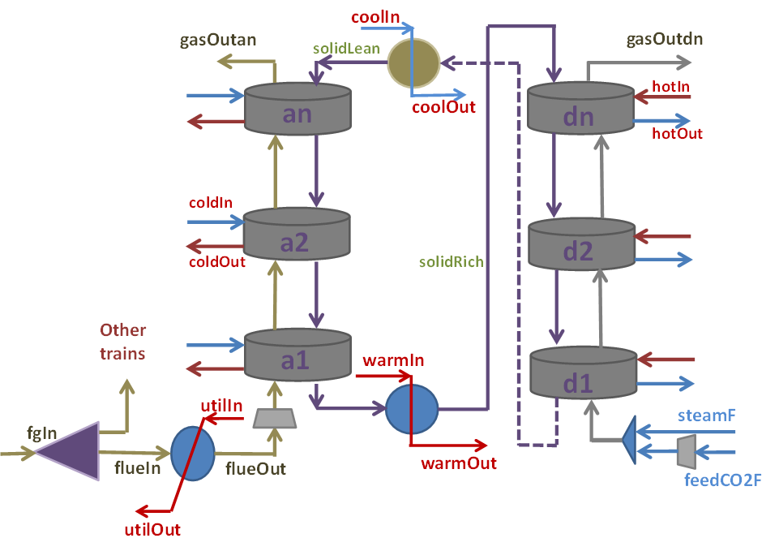

Figure : General flowsheet for a carbon capture process.

* 1. Superstructure Formulation Assumptions

The main objective of the model is to minimize the total cost, which includes capital, operating, maintenance, utilities, and power costs to achieve at least a 90% CO2 capture target. The superstructure is formulated based on the following assumptions:

* Each stage is a single-stage operation
* Each stage requires an attached heat exchanger
* A blower is needed before the first stage of the adsorber and regenerator only
* No pressure change occurs for liquid and solid flows
* The utility cost for the sorbent heat exchanger is negligible
  1. Superstructure Formulation

In this section, a comprehensive description of the superstructure formulation is provided. Figure 2 illustrates an outline of the superstructure formulation, which can be divided into five parts: (1) the initial definition, (2) economic modules, (3) links between economic modules and process modules, (4) process modules, and (5) bounds for variables.

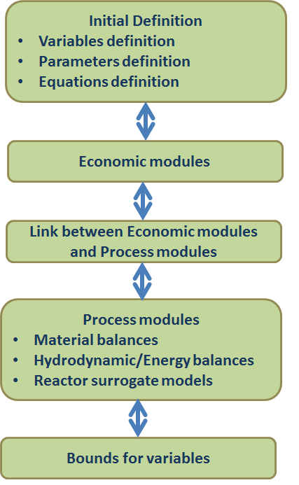

Figure : Components of the Superstructure Formulation.

**Initial definitions**: Part 1 includes the inlet conditions of flue gas, thermochemical/physical parameters, and definitions of design/operating variables.

**Economic modules**: In the preliminary version, the objective function minimizes the cost of electricity due to capture (COE). In Part 2, the economic modules include the following economic indicators (as shown in Table 1):

Table : Economic Modules’ Indicators

| Variable | Meaning |
| --- | --- |
| derate | Derating of the plant due to steam take-off |
| steamflow | Steam take-off amount from power plant |
| CapEx | Capital overnight cost |
| unitCpa | FOB cost of adsorber stage |
| unitCpd | FOB cost of regenerator stage |
| unitW | Vessel weight |
| unitPb | Blower power |
| unitPe | Elevator power |

**Links between process modules and economic modules**: In Part 3, economic equations are built to connect the process modules and the economic modules.

**Process modules**: In Part 4, to simplify the complexity of the optimization problem, surrogate models are assumed for the mass balances of the reactors and flue gas heat exchanger. The energy balances of the reactors are also approximated by surrogate models, while first principle models are used to model the compressors, mixers, and heat exchangers (solidLean and solidRich).

(a) Models for flue gas heat exchanger shown in Figure 3.



Figure : Flue gas heat exchanger.

Hydrodynamic/Energy Balances

|  |  |
| --- | --- |
|  | (1) |
|  | (2) |

Mass Balances

|  |  |
| --- | --- |
|  | (3) |

Flue Gas Heat Exchanger

|  |  |
| --- | --- |
|  | (4) |
|  | (5) |

where,  and  are the pressure of the flue gas outlet changing around the heat exchanger,  denotes the flowrate of the flue gas to heat exchanger,  and  are the inlet temperature and outlet temperature of the flue gas,  is the set of flue gas components (),  is the cooling water flowrate,  and  are the inlet and outlet temperatures of the cooling water,  is the condenser heat transfer coefficient,  is the heat exchanger area,  is the heat capacity of water, and  denotes the total flue gas flowrate from the power plant.

(b) Surrogate models for adsorbers shown in Figure 4.



Figure : The sth adsorber.

The material balances in each adsorption stage are given by the following surrogate models:

|  |  |
| --- | --- |
|  | (6) |
|  | (7) |
|  | (8) |
|  | (9) |

where,  denotes the fractional molar composition of component *fc* in the outlet gas stream from stage *s*,  is the outlet flow rate of the gas stream from *s*,  is the fractional molar composition of component *fc* in the outlet sorbent stream from stage *s*,  denotes the outlet sorbent fraction from stage *s*, and  is the sorbent flow rate.

The hydrodynamic/energy balances of gas flow in each adsorber are given by the following surrogate models:

|  |  |
| --- | --- |
|  | (10) |
|  | (11) |
|  | (12) |
|  | (13) |

where  and  are the inlet and outlet temperatures of the gas stream around stage *s*,  and  are the inlet and outlet pressures of the gas stream around stage *s*,  and  are the inlet and outlet temperatures of the cold water around stage *s*,  is the cold water flowrate to stage *s*, and   are the inlet/outlet temperatures of sorbent streams from stage “s.”

The geometry of the reactor is represented by surrogate models:

|  |  |
| --- | --- |
|  | (14) |

where  represents the tube pitch in stage *s*,  denotes the number of heat exchanger tubes,  is the diameter of heat exchanger tube, and  is the superficial gas velocity.

(c) Surrogate models for regenerators shown in Figure 5.



Figure : The dth regenerator.

The material balances in each regenerator are given by the following surrogate models:

|  |  |
| --- | --- |
|  | (15) |
|  | (16) |
|  | (17) |
|  | (18) |

where  denotes the fractional molar composition of component *fc* in the outlet gas stream from stage *d*,  and  denote the gas stream flowrates around stage *d*,  is the fractional molar composition of component *fc* in the inlet gas stream to stage *d*,  is the fractional molar composition of component *fc* in the sorbent stream from stage *d*,  is the outlet sorbent fraction from stage *d*, and  is the fractional molar composition of component *sc* in the outlet sorbent stream from stage *d*.

The hydrodynamic/energy balances of gas flow in each regenerator are given by surrogate models:

|  |  |
| --- | --- |
|  | (19) |
|  | (20) |
|  | (21) |
|  | (22) |

where  and  are the inlet and outlet temperatures of the gas stream around stage *d*,  and  are the inlet and outlet pressures of the gas stream around stage *d*.  denotes the outlet temperatures of sorbent streams from stage *d*,  and  are the inlet and outlet temperatures of hot water around stage *d*, and  is the hot water flowrate to stage *d*.

The geometry of the reactor is represented by a surrogate model:

|  |  |
| --- | --- |
|  | (23) |

where  represents the tube pitch in stage *d*,  the number of heat exchanger tubes, and  the superficial gas velocity.

(d) Energy balance for solidRich heat exchanger shown in Figure 6.



Figure : The solidRich heat exchanger.

|  |  |
| --- | --- |
|  | (24) |

where  is the heat capacity of the sorbent,  is the outlet temperature of sorbent from the solidRich heat exchanger,  is the heat transfer coefficient for solid sorbent, and  is the solidRich heat exchanger area.

(e) Energy balance for solidLean heat exchanger shown in Figure 7.



Figure : The solidLean heat exchanger.

|  |  |
| --- | --- |
|  | (25) |

where,  represents the heat capacity of sorbent,  is the outlet temperature of sorbent from the solidLean heat exchanger,  is the inlet temperature of sorbent to the heat exchanger, and  is the solidLean heat exchanger area.

**Bounds of variables**: In Part 5, the bounds of design/operation variables and economic variables are set. In addition, the CO2 capture rate is added as a constraint in the formulation.

The above five parts comprise a nonlinear programming model. The detailed steps to debug such a formulation are discussed in the following sections.

* 1. Model Features

1. Surogate models - adsorbers and regeneration units:
   1. Data sampling: ~2000 sample points have been generated using the uncertainty module of FOQUS and simulated using Aspen Custom Modeler for each technology.
   2. Surrogate models have been obtained exploiting the new features of ALAMO (i.e., sample generation, constrained regression, linear error method, and evaluating using different MINLP solvers).
   3. A nonlinear least square optimization model has been solved to improve the fitting of the models proposed by ALAMO.
   4. Variables definition: lower bounds, upper bounds, and initial values have been updated for adsorber and regenerator units.
2. Superstructure design optimization, main assumptions:
   1. The maximum and minimum adsorption levels of CO2 are considered (predicted based on the data set studied).
   2. Inlet Sorbent flow is different for the adsorbers and regenerators.
   3. The regeneration units use two times the sorbent flow than the adsorbers. Hence, half of the number parallel trains are considered to be installed for the regenerators.
   4. Unit Length: is lower than the unit diameter, and at least two times the length of the solids bed in each unit (adsorber or regenerator).
3. A sensitivity analysis is studied, in which the user can obtain an optimal design under different initial conditions.
   1. Superstructure optimization tool

The current formulation is based exclusively on the use of fluidized bed technology. The surrogate models have been developed under certain conditions. Thus, the surrogate models are valid for the variable bounds (upper and lower bounds) used during the preparation of the data set.

Two main features of the model can be exploited by the users:

1. Modifications to enable the use of different sets of surrogates, representing the adsorber and regenerator with different levels of accuracy, can be made.
2. The user can obtain an optimal design under different conditions and requirements.
   1. Next Steps

There are two main lines of research. The first line focuses on the extension of the model capabilities in two ways: (1) allowing the selection of different reactor types, (i.e., a fluidized bed reactor and a moving bed reactor). (2) extending the model as a multi-objective optimization framework to look for the tradeoff between CO2 capture target and total cost.

The second research line, relies on the improvement of the current process model in two ways: (1) improving the cost estimation, a preliminary version of an improved cost model is included in this release and (2) improving the model by including behavior constraints to predict the size of the units, CO2 capture, solids regeneration levels, etc. These behavior constraints should be based on the data set obtained for the preparation of the surrogate models.

1. Basic Model Features

In this section, each feature mentioned in Section 2.5 is demonstrated with small examples. The description for illustrating these features follows the GAMS language style. In this model, “a” denotes an adsorber, and “d” a regenerator.

**GAMS start up and running:**

1. Download the Superstructure bundle documentation
2. Extract the zip files in the directory of your convenience (readme.docsx describes the contents of the zip file).
3. Locate the minlp directory (see Figure 8).
   1. The surrogate models folder includes the data sets, variables bounds, and surrogate models obtained using ALAMO (surrogate modeling tool), FOQUS session (data generation, data sampling – simulator Interface, ALAMO input file generator, etc.), and BFB model.
   2. Supr_final_proj.gpr is the GAMS project file.
   3. Super-2016-windows_wf.gms file is the main optimization code. This file includes the variables & constraints declaration, calls the Regenerator_vf.gms and Adsorber_vf.gms, and initialization procedure.
   4. Regenerator_vf.gms file includes the surrogate models for the Regeneration units
   5. Adsorber_vf.gms file includes the surrogate models for the adsorber units.
   6. Superstructure_results.xlsx file saves the main results after the optimization (COE, FOB costs, plant design (units installed), and the optimization statistics (CPU time, optimality, etc.). This file is updated after the optimization terminates, so, it must be closed until GAMS terminates (otherwise the results won’t be updated).

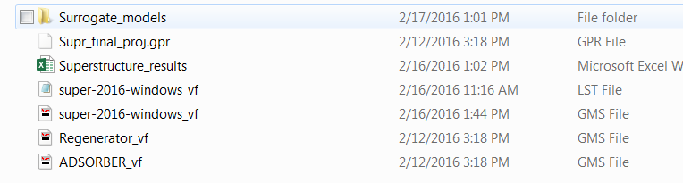

Figure . minlp directory description

1. GAMS
   1. Open the GAMS IDE from windows start menu.
   2. Open the project file Supr_final_proj.gpr (see Figure 9).
      1. File\Project\Open Project (search your directory and select Supr_final_proj.gpr).

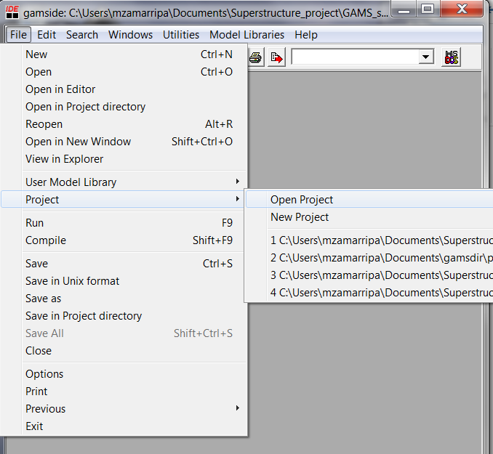

Figure . Open project

* 1. Open the main code (super-2016-windows_vf.gms, see Figure 10)
     1. Click Open file browser (upper left corner).
     2. Select the main optimization code file (super-2016-windows_vf.gms) and click open.
     3. When the project file is open, GAMS works directly in the minlp directory. If the user do not open the project file, errors will arise during the execution.

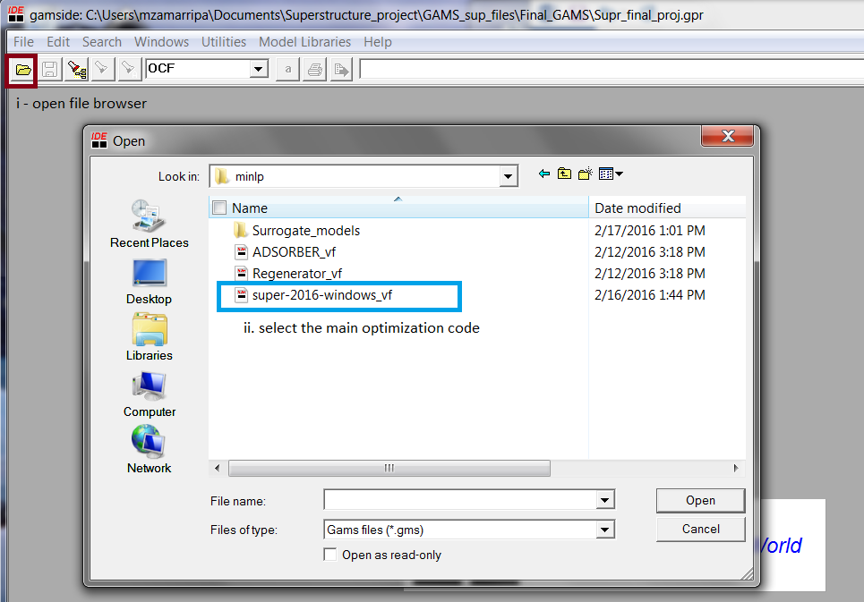

Figure . Open file browser

* + 1. **Comments** are characterized by gray text (using $ontext to open the comments, and $offtext to close the comments). (see Figure 11)
    2. **Comments** are also included by * at the beginning of the line.
    3. **Declarations** (sets, variables, scalars, parameters, etc.) are characterized by bold blue text. The user terminates the declaration with “;” at the end of the line (otherwise an error is obtained). (see Figure 11)
    4. Blue text are used to describe the declarations, and green text corresponds to the value of the declaration. (see Figure 11)
    5. Click run (or click F9) and analyze the results either in GAMS or in the spreadsheet. (see Figure 11)

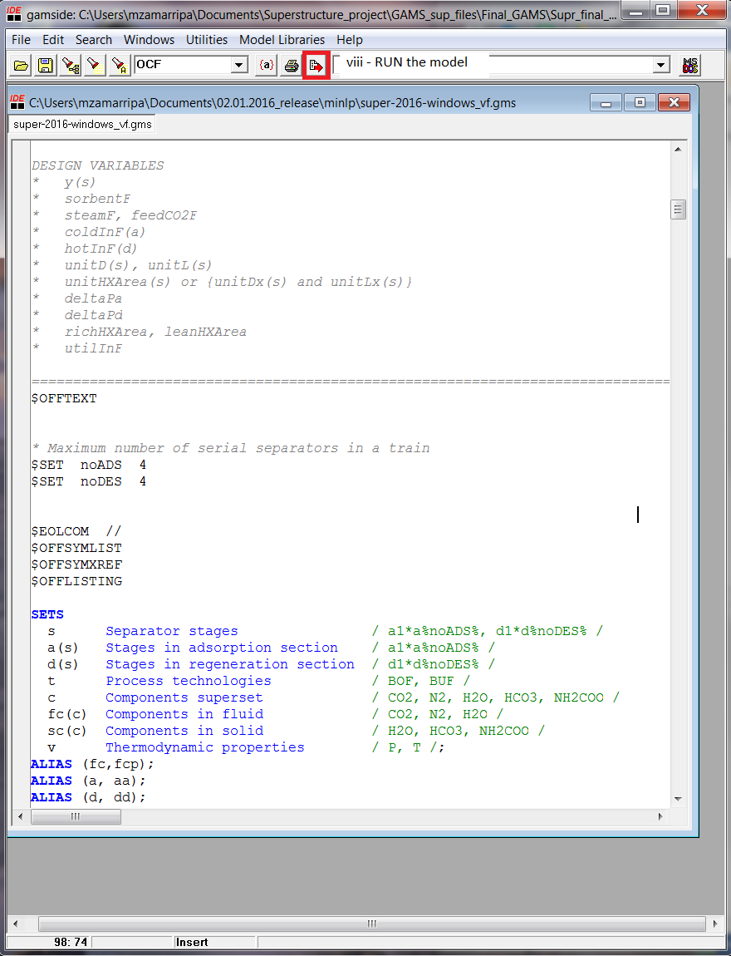

Figure . Superstructure optimization model declaration

* 1. After GAMS execution the listing file is automatically loaded to GAMS environment. The user can navigate with the panel on the left and the selection is displayed on the right side of the screen. (see Figure 12)
     1. **Compilation** section includes all the sets, parameters, variables, equations, and extra statements.
     2. **Equation** **listing** displays the initial value for all the equations (important to observe the variables listed in each equation).
     3. **Column** displays the all variables used in each equation.
     4. **Model Statistics** shows a summary of the model, including relevant information like: block of equations and variables, number of variables, discrete variables, nonlinear terms, etc.
     5. **Solution Report** displays a summary of the model results, such as: objective value, CPU time, absolute and relative optimality gap, etc.
     6. **SolEQU** – lower and upper bound, level and marginal value of the equation.
     7. **SolVAR** – lower & upper bound, level – final solution of the variable, and marginal value – which can be considered as shadow price (that shows the impact in the objective function by a unit change in the variable).
     8. **Display** – Since models can become very large, the user can select a set of variables/parameters to be shown in this section. The user will observe the superstructure optimization main results (COE, soi, y, Nu, x, CaptureTarget, derate, Steam Flow, and plant costs).

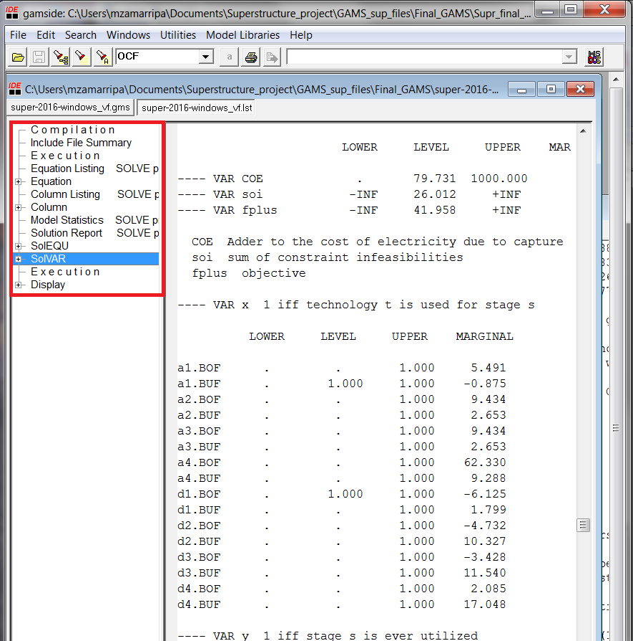

Figure . Listing file navigation

* 1. Feature 1: Use of Different Surrogate Models

Description

Modifications can be made to enable the use of different sets of surrogates representing the flue gas heat exchanger, adsorber, and regenerator with different levels of accuracy. In order to simplify the complexity of the optimization problem, surrogate models from ALAMO are assumed for the mass/energy balances of the flue gas heat exchanger, adsorber, and regenerator. The user can easily insert different surrogates into the process module part of the formulation.

**Note:** If the user wants to replace the surrogate models of adsorber and regenerator, please ensure that the units are consistent in all these models.

Examples

The surrogate models are divided in five groups, including: (1) the flue gas flowrate, (2) sorbent fraction, (3) thermochemical properties, (4) fractional molar composition, and (5) geometry variables. The following are general examples for the surrogate model of the fluidized bed adsorber and regenerator.

|  |
| --- |
| * BFB Adsorber Surrogate Model |
| BFBads1(a) $ ads('1') .. Outlet flowrate of flue gas from adsorber=E= surrogate model |
| BFBads2(a) $ ads('2') .. Outlet sorbent fraction from adsorber=E= surrogate model |
| BFBads3(a) $ ads('3') .. Thermochemical properties of flue gas =E= surrogate model |
| BFBads4(a) $ ads('4') .. Thermochemical properties of solid sorbent =E= surrogate model |
| BFBads5(a) $ ads(‘5’) .. Outlet fractional molar composition of flue gas =E= surrogate model |
| BFBads6(a) $ ads(‘6’) .. Outlet fractional molar composition of Solid sorbent =E= surrogate model |
| BFBads7(a) $ ads(‘7’) .. Geometry variables =E= surrogate model |
|  |
| * BFB Regenerator Surrogate Model |
| BFBDes1(d) $ des('1') .. Outlet flowrate of flue gas from regenerator=E= surrogate model |
| BFBDes2(d) $ des('2') .. Outlet sorbent fraction from regenerator =E= surrogate model |
| BFBDes3(d) $ des('3') .. Thermochemical properties of flue gas =E= surrogate model |
| BFBDes4(d) $ des('4') .. Thermochemical properties of solid sorbent =E= surrogate model |
| BFBDes5(d) $ des('5') .. Outlet fractional molar composition of flue gas =E= surrogate model |
| BFBDes6(d) $ des('6') .. Outlet fractional molar composition of solid sorbent =E= surrogate model |
| BFBDes7(d) $ des('7') .. Geometry variables =E= surrogate model |

* 1. Feature 2: Optimization can be Carried Out under Different Requirements

Description

The user can obtain the optimal design under different conditions and requirements. Mixed Integer   
Non-Linear Programming (MINLP) solvers require the modeler to provide bounded variables and expressions for the model to be reliably solved. The best way to provide these bounds is to supply physically meaningful ranges for all problem variables using the .lo and .up variable attributes in the GAMS file.

|  |
| --- |
| Lower bound: (variable).lo = value; |
| Upper bound: (variable).up = value; |

To seek optimal design results under the specific conditions and requirements, modify lower and/or upper bounds of the relevant variables or reset other model parameters, and then run the revised MINLP formulation.

Examples

In the SCALARS section and the PARAMETERS section of the MINLP formulation, the inlet flue gas conditions, including the total flowrate, temperatures/pressure, mole fractions, and other physical properties are listed. For example,

|  |
| --- |
| fgF Total flow rate of flue gas (kgmol per sec) / value/ |
| fgC(fc) Mole fractions of flue gas / CO2 = value, N2 = value, H2O = value / |
| fgV(v) P and T of flue gas from power plant / P = value, T = value / |

By running the MINLP formulation, the optimal results based on the above conditions are achieved. If the user wants to analyze the influence of inlet flue gas conditions on the optimal solution, only the value of the fgC(fc) variable and the execution ad summary of results from GAMS code needs to be revised.

The surrogate models of the adsorber and regenerator are generated with ALAMO based on the data set from an ASPEN simulation. If the user wants to revise parameters to analyze the effect of flowrates and geometry on the optimal solution, please ensure that the modified parameters are not outside the range over which the surrogate models were derived. Otherwise, the existing model is used in extrapolation mode and may yield results of unpredictable quality.

1. Debugging

In this section, detailed debugging steps for running a modified superstructure formulation, which is developed with the GAMS language, is presented. To use and run this program, users need to download and install the GAMS software from: <http://gams.com/download>. A GAMS license is needed for this purpose. Current MINLP solvers provided under GAMS include BARON, DICOPT, LINDOGLOBAL, SBB, and SCIP. Comprehensive guidelines for developing and running GAMS code can be found in <http://www.gams.com/help/index.jsp>.

* 1. How to Debug

Personal Computers

1. GAMS distribution. If the user does not have a copy of GAMS, download the software from <http://gams.com/download>. Detailed guidelines for installation can be found at the GAMS website: <http://gams.com/docs/win-install.html>.
2. After installation of the GAMS software, the user can revise the GAMS file for the superstructure formulation or open the existing model.
3. **Solvers selection**. In the current version of MINLP formulation, dicopt is used as the MINLP solver to get the solution.

|  |
| --- |
| option MINLP=dicopt; |
| option reslim=3600; |
| SOLVE ProSyn USING MINLP MINIMIZING fplus; |

1. **GAMS-IDE opens the output listing file**. For example, if the user runs the GAMS file super.gms, which includes the superstructure formulation, once the run is completed, the listing file super.lst is automatically generated.
2. **Model information and errors detection**. Before errors are detected, it is best to save the file with a new name (e.g., gms) to copy the original error-free code. The output listing file (name.lst) offers detailed information about the GAMS code and also lists any errors that require attention. Typically, the name.lst file contains five parts in the following order:
3. The contents of name.gms
4. A listing of all equations
5. Model statistics
6. Solve summary
7. Solution Report

**Model Statistics**. As the following example illustrates, summary model size and type information are provided, including the number of equations and variables. The Solve Summary lists the name of the model, objective variable, solver used, and the type of model and solver. If the maximum number of adsorbers and regenerators are set to equal four, the corresponding model statistics are as follows:

|  |  |  |  |
| --- | --- | --- | --- |
| Model Statistics | SOLVE ProSyn | Using MINLP From Line 773 | |
| MODEL STATISTICS |  |  |  |
| BLOCKS OF EQUATIONS | 72 | SINGLE EQUATIONS | 323 |
| BLOCKS OF VARIABLES | 66 | SINGLE VARIABLES | 942 232 projected |
| NON ZERO ELEMENTS | 2,464 | NON LINEAR N-Z | 1,210 |
| DERIVATIVE POOL | 10 | CONSTANT POOL | 226 |
| CODE LENGTH | 5,763 | DISCRETE VARIABLES | 9 |

GAMS adds a coded error message under a model line if there is an error in this line. The coded error messages are designated by **** followed by $, and one or more numerical error codes follows the dollar sign. The detailed error information is explained in the error messages section of the name.lst file. For example:

|  |
| --- |
| **** $170 Domain violation for element |

In the above example, “170” is the numerical error code that corresponds to the particular error encountered and “Domain violation for element” suggests what GAMS believes is the cause of the error.

1. **Final solution list.** Once all errors of the modified model have been corrected successfully, the solution report, which provides the optimal values of all variables, is given. The Solve Summary notifies the user if the model is solved or not. For example, if DICOPT as MINLP solver is used, the relevant solve summary is as follows:

|  |  |
| --- | --- |
| Solve Summary |  |
| MODEL ProSyn | OBJECTIVE fplus |
| TYPE MINLP | DIRECTION MINIMIZE |
| SOLVER DICOPT | FROM LINE 783 |
| ****SOLVER STATUS | 1 Normal Completion |
| ****MODEL STATUS | 8 Integer Solution |
| ****OBJECTIVE VALUE | 19737.8372 |

If a personal computer is not used to compile and run the superstructure formulation code, follow the debugging steps below:

1. Open the terminal platform, and type the path of the superstructure formulation to the gams file as “>> cd path”.
2. Use the following commands to select the solvers:  
   >> gams *name.gms* Sys12=1 ExecErr=1e9 minlp=Solver

For example, if BARON is used to solve the *super.gms* file to seek the optimal results, type the command:  
>> gams *super.gms* Sys12=1 ExecErr=1e9 minlp=baron

Once the above command has been typed, the *super.lst* file is generated in the same path of the *super.gms* file.

1. The next steps are the same as Steps 5 and 6 discussed above.
2. Case study

The case study used to show the capabilities of the superstructure formulation is based on the adsorber 650.1 subsystem process model. The model goal is to remove at least 90% of CO2 and is based on the design and optimization of a full-scale design of a solid sorbent capture system for a net 650 MW (before capture) supercritical pulverized coal power plant (This model is protected under CCSI MASTER NDA-1107306). The A650.1 model describes a solid sorbent-based carbon capture system that uses the NETL-32D sorbent, in which the CO2 removal is achieved through chemical reactions between the amine sites within the solid sorbent. The A650.1 model is implemented in Aspen Custom Modeler (ACM) and contains many components (e.g., adsorbers, regenerators, compressors, heat exchangers).

The design of the carbon capture plant is optimized using the superstructure formulation developed in this work. The formulation considers the installation of 12 to 16 parallel units, each parallel unit can be equipped with up to 4 adsorbers beds and 4 regenerators beds. The inlet flue gas conditions, such as pressure, mole fractions (N2, H2O and CO2), and inlet molar flow rate are known.

Since the MINLP solver cannot guarantee a global optimal solution, the superstructure formulation was tested under different initialization values and fixing the number of parallel units to be installed (Nu – integer variable with values of 12, 14, and 16). As a result of the proposed sensitivity analysis, the optimal design and operation of the CO2 capture plant are obtained. Table 2 shows the summary of costs for each design. Since, the results correspond to a local optima the results can change after each run. As mentioned above global optimality of the results cannot be proved. Table 3 shows the economic parameters, inlet properties of the flue gas, and other parameters used in the model.

The COE is a function of total overnight cost (TOC), fixed operation and maintenance (O&M) costs, variable O&M (including fuel) costs, and annual net megawatt-hours of energy (*MWh*) that is generated at a 100% capacity factor.



where, CCF is the capital charge factor, CF is the plant capacity factor, and COETS&M is the cost for CO2 transport, storage, and monitoring. TOC can be computed from the equipment design variables. For example, the cost of an adsorption unit can be estimated from the number of stages, the depth of the beds, the diameter of the vessel, and the number and size of the immersed heat exchange tubes. Cost correlations were used to calculate FOB cost for major equipment and a Lang factor was applied to obtain TOC. O&M costs were estimated using information from the process or as a fraction of the TOC (e.g., labor cost).

Table . Summary of results

|  |  |  |  |
| --- | --- | --- | --- |
| Parallel trains (Nu) | 12 | 14 | 16 |
| COE | 78.17088 | 79.74946 | 81.4591 |
| Capture Target (%) | 90 | 90 | 90 |
| (CCF)(TOC) | 23787.93 | 24046.13 | 24343.49 |
| (OCfix) | 5547.667 | 5595.492 | 5650.57 |
| (CF)(OCvar) | 12881.74 | 12898.4 | 12917.58 |
| (CF)(MWh) | 597.6332 | 589.0381 | 580.4431 |
| COETS&M | 7.53 | 7.53 | 7.53 |
| FOB cost of Adsorber ($) | 398681.2 | 393336.8 | 389116.9 |
| FOB cost of Regenerate ($) | 320578.2 | 320578.2 | 320578.2 |

Table . Model Parameters

|  |  |  |  |  |
| --- | --- | --- | --- | --- |
| Parameter | Description | | Value | Units |
| **Economic Module** | | | | |
| OCF | Overnight cost factor | | 5.82 | Annualized cost ($) |
| CRF | Capital recovery factor | | 0.124 | Dimensionless |
| MOD | Capital maintenance | | 0.0828 | Annualized cost ($) |
| OW | Operation wages | | 40 | $ per hour |
| OD | Overhead labor | | 1.5 | $ per hour |
| Rho | Carbon steel density | | 490 | lbs./ft3 |
| Cfsteel | Carbon steel fabrication factor | | 1 | - |
| CF | Capacity factor | | 0.85 | - |
| K | Ratio of specific heats of diatomic gas | | 1.4 | Cp/Cv |
| Np | Nameplate capacity before capture | | 650 | MW |
| Ps | Space between MB reactor plates | | 0.656 | ft. |
| Ew | Elevator width | | 12 | in |
| Wt | Wall thickness | | 0.104 | ft. |
| V | Bound on maximum superficial gas velocity | | 4 | m/s |
| SCp | Sorbent heat capacity | | 1.13 | kJ/Km2 |
| SU | Sorbent heat transfer coeff. | | 0.3 | kW/Km2 |
| cnU | Condenser heat transfer coeff | | 0.1 | kW/Km2 |
| **Flue Gas** | | | | |
| Pressure | Pressure from power plant | | 1.01 | atm |
| Temperature | Temp. from power plant | | 54.18 | C |
| FgC | Flue gas mole fractions | CO2 | 0.12 | % |
| N2 | 0.74 | % |
| H2O | 0.14 | % |
| GCp | Specific heat capacity | CO2 | 41.3 | kJ/kmolK |
| N2 | 29.2 | kJ/kmolK |
| H2O | 34.2 | kJ/kmolK |
| **Others** | | | | |
| Pst | Steam inlet pressure | | 6.8 | atm |
| Tst | Steam inlet temperature | | 170 | C |
| CoolantT | Coolant inlet temperature | | 32.22 | C |